Food Allergens Laboratories

‘'International Network of Analytical Laboratories with specilazation in Food, Feed and Water Testing, with more than 20 people scientific staff in Greece, Cyprus and Poland. The highly competitive prices and the reliable and fast results are due both to the modern equipment and the accreditation by ESYD in accordance with ISO / IEC 17025: 2005.’’

**1. HOME**

**image 1:**

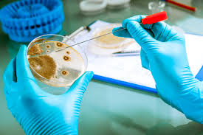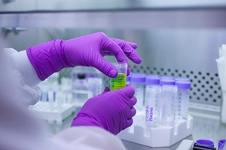

title: **Laboratory Analysis**

Short description: With four independent laboratories in Greece, Cyprus and Poland, and a continuously expanded accreditation scope, we are able to offer you a wide range of specialized chemical, immunochemical, molecular and microbiological analyzes in food, beverages, animal feed, dietary supplements, cosmetics, drugs and environmental samples.

link to sub-menu:

**image 2:**

Title: **Equipment & Consumables**

Short description: We can provide you any kind of laboratory equipment and consumable products while at the same time we are specialized in rapid diagnostics tests produced by reliable and well-known international firms.

link to sub-menu:

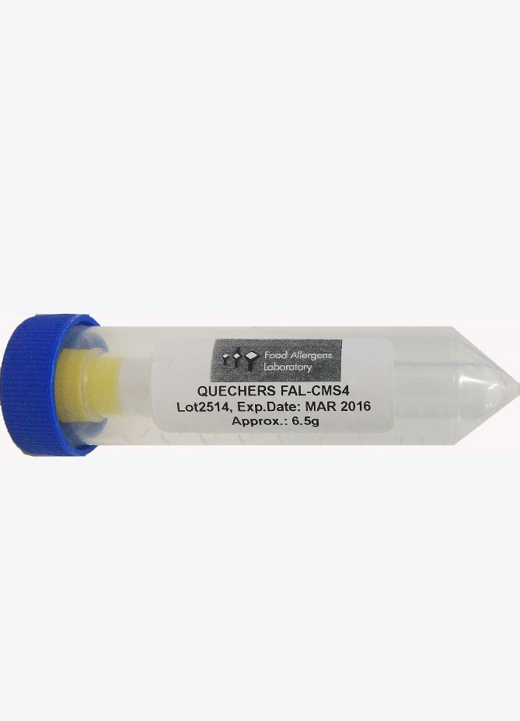image **3:** 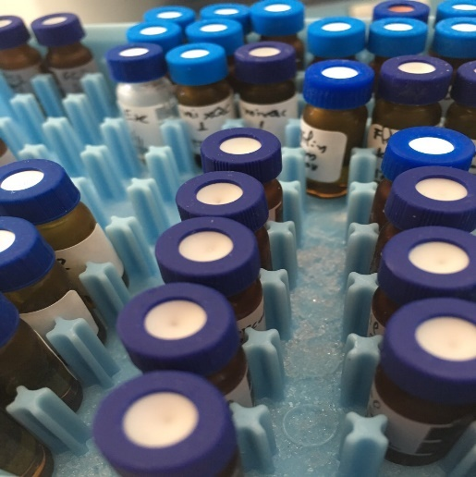

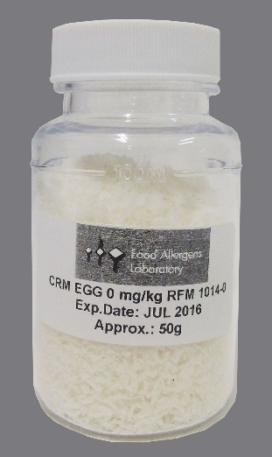

Title: **Production & Distribution of CRMs & QuEChERS**

Short description: We are specialized in the production Reference Materials (RFMs) with specified values of certain parameters, for the validation and verification of food allergens measurement methods. Also we produce QuEChERS products for the analysis of several compounds like pesticides, pharmaceuticals, mycotoxins, PAHs, etc.

**image 4:**

**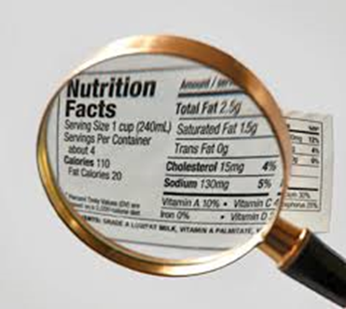****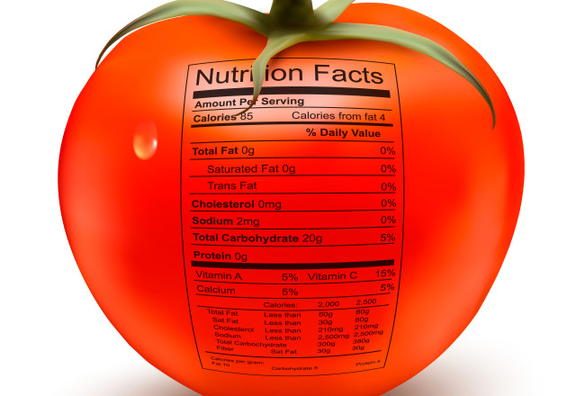**

Title: **Labeling Control**

Short description: Our Food-Law department provides full check for the compatibility of labeling information provided with the relevant requirements of the existing legislation in EU and USA. In the same frame we can also support you with all the necessary tests for each case as well as with the respective services where needed (portion sizes/ daily intake percentages)

link to sub-menu:

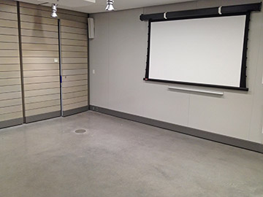**image 5:**

Title: Trainings and Seminars

Short description: With over 20 years of experience in professional training the scientific staff of the Food Allergens Lab is able to offer you well-organized training services to a wide range of subjects with courses aimed at both companies and professionals as well as at independent individuals and students in the food & beverage sectors.

link to sub-menu:

**image 6:**

Title: Law Services, Research and Development

Short description: We provide full and updated support in all food legislation issues, regarding food, beverages and dietary supplements. Furthermore, our highly qualified staff is involved in several research programs with enterprises and institutions aiming at the development of new and innovative methods and products in the food sector.

link to sub-menu::

**2. THE COMPANY**

**Profile**

Food Allergens Labs consist of 4 independent laboratories, 2 of them located in central and southern Greece and one each in Cyprus and Poland. The company applies internationally recognized quality management systems in compliance with the standard **EN** **ISO 9001** while the tests made are under the international standard **ISO/IEC 17025:2005** and certified by the National Accreditation System (**ESYD**) with the accreditation field to be expanded continuously. Food Allergens Labs are also recognized by the International Olive Oil Council (**IOOC**), the European Federation of Vegetable Oil and Protein-meal Industry (**FEDIOL**) and the International Dairy Federation (**FIL-IDF**). Last year we expanded our field of activities with the authorization by the National Drug Agency (**EOF**) for laboratory analyses in food supplements and cosmetics. Last but not least, we are one of the 100 labs which have been approved by fruitmonitoring and GS1 standard for pesticides residues testing in fruits and vegetables worldwide.

Besides this wide-range of specialized laboratory testing (chemical, immune-chemical, molecular and microbiological) we are operate in parallel to the trade of special equipment and consumables for the quality control in food, supplements and cosmetics businesses, private laboratories and research institutions. As exclusive representatives of several international firms with good reputation and credibility (like Neogen, Megazyme, Operon, Accumax, Biosan, Biomedal, Generon etc), in Greece, Cyprus and Poland, we are experts in the field of rapid diagnostics systems.

Finally, in the specially designed laboratory in Cyprus operates the production department of Certified Reference Materials (FAL-RMS®) and Special Extraction Salts (FAL-QuEChERS®) which we are trade internationally in more than 34 countries covering various needs of food businesses and other private and public quality control laboratories.

**History**

The company was founded in 2005 in Rethymnon, Crete, by Mr. Andreas Varlamos (Chemical Engineer NTUA, MSc Food QA Reading UK) and Mr. George Seiragakis (Food Chemist MSc) who are profesionals with more than 20 years of experience in the food processing industry as well as in training and inspections sector.

The second laboratory was established in Neo Heraklion, Athens in early 2008, followed by the it’s relocation to Nea Ionia in late 2013 where it stands until today on the 4th and 5th floor of 40 K. Varnali str.

In late 2008 started the operation of the fist laboratory in Cyprus at the region of Larnaca FA Food Allergens Lab Ltd, where apart from laboratory analysis a production department for the CRMs and the QuEChERS was created. In early 2016, having increased demand from the food industry in Central Europe both in services and in trade, the latest unit in Warsaw was established with the distinctive title Food Allergens Lab Polska SP. ZO.O.

**Infrastructures**

The Food Allergens Laboratories are equipped with the most modern laboratory equipment in all operating levels (eg. LC-MS/MS, GC-MS/MS, HPLC, RP-HPLC, ICP-OES, GC-ECD, GC-FID, UV-ViS, PCR, Real Time PCR, Εlisa Reader, Tissue Lyser, Soleris, ANSR etc). Of course, the use of such a special equipment requires higly trained scientific staff both to ensure proper operation and security as well as to guarantee proper assessment of the outputs and prevention of any adverse interactions and costly errors. We are proud of the high scientific level of our staff with the great work experience available, which enable us to test more than 15,000 samples each year and making us one of the most important laboratories in the field of food analysis, food supplements in the South-East Europe. Such an assertion can easily be proofed by the continuous involvement of our personnel in several activities of national and European organizations such as, EFSA, CEN, VEUC, TEE, CC, ESYD, as well as their presence in all leading international events such as exhibitions, conferences, scientific journals, etc.

**Vision-Mission-Values**

**Our Philosophy** is that quality control is the key point in the production and promotion of a product which will fulfill costumers needs while this process will result the expected benefits to the companies. We are always operate on the basis of our established principles and values that include the reliability of our services, the transparency of our procedures and the confidence in all forms of our partnerships (staff, partners, suppliers and customers).

**Our vision** is to become the best company in the area of our activity, both in terms of reliability and speed of our services, but also in the constant techno-economic benefit of our customers so as to mutual benefit them as well as and also the staff of our laboratories.

**Our mission** is to provide reliable, economic and fast services in order to benefit and to fully satisfy our customers in terms of technical and economic approach. This means to provide reliable and validated assays, to supply high quality products and update trustworthy advisory services.

**Our total quality policy** is governed by a set of principles for which we fight daily:

- Customer focus (Fulfil of needs-desires, value-added services principle, innovative solutions-options)

- Priority to Quality (Total Quality Standard, focusing on the production of reliable, timely and reliable results and products)

- Allocation of Competencies & Team Spirit (talented, Qualified & Experienced staff with continuous training and recognized performance)

- Confidentiality-Integrity (Our ethical principles set out all of our trade and economic activities beating staff and customer respect)

**Corporate Social Responsibility**

In the Food Allergens Labs laboratories, we are committed to the highest ethical standards in the conduct of our services within the global social responsibility. Our primary concern is to provide services with professionalism, in respect to our quality promises for the benefit of our customers and indirectly of the society, always on the basis of legality required for administrative, financial, labor and environmental compliance to laws and rules. Maintaining our intercompany relations for keeping the above principles is central to the achievement and continuous improvement of the quality of our services. Our philosophy, mission, principles and values, are define our commitment to professional and ethical behavior while they are keeping us under constant development and innovation.

**3. PRODUCTS & SERVICES**

**Laboratory Testing**

Our laboratories in Athens, Rethymnon, Larnaca and Warsaw and our collaborations with other international laboratories in Germany, Holland and Italy allow us to cover the whole range of the required laboratory tests on any substrate such as **Food & Beverages** (Fruits, Vegetables, Legumes , Cereals, nuts, Oil, Olives, Meat, Sausage, Milk, flour, Bread, Pasta, Honey, Confectionery Products etc.), **Feed**, Water, Waste-Biological Treatment, Soil, Leaves, Plant tissues and **Supplements**.

Indicatively, the following table lists some of the main tests we perform:

|  |  |
| --- | --- |
| Advanced Immunochemical and Molecular Techniques (Allergens, Antibiotics, GMOs, Microbiological tests) | Specialized Detection of Pesticide Residues (Insecticides, Herbicides, Biocides) |
| Modern Chromatographic Techniques  (Phthalate esters, PAHs, Mycotoxins, additives) | Special Spectrometric Techniques  (Amino Acids, Vitamins, Metals-Minerals, Polyphenols) |
|  |  |
| Nutritional Information (EU, UAE, USA, CHINA) | Shelf life Assessment (ADSL tests) |
|  |  |
| Food Fraud, Supplements & Feed Adulterations  (Dairy products, Honey, Olive oil, Herbs & Spices, etc) | Quality Sets for several products  (Olive oil, Honey, Dairy products, Water, Soil) |
| Contaminants (Acrylamide, Heavy Metals, Dioxins, PCBs, PAHs, Amines, Histamine, Mycotoxins, Nitrates) | Plant Species main quality characteristics  (Essential oils, Pollen, Aloin, Steviol, Coumarin) |
| Food Contact Materials (Overall & Specific Migration) | Soil, Leaves and Irrigation testing |

* Each test is a link refers to the applied method, the available substrates, the required amount of sample, time, accreditation etc. And inquiry button ...

**Quality Control Equipment**

Having secured the exclusive distribution of several leading brands in food and feed safety, we are extremely specialized in rapid detection methods (kits) offering ideal solutions for the Quality Control in all types of Food Industry. In addition, we can offer plenty solutions in the trade, establishment and training in any kind of laboratory equipment.

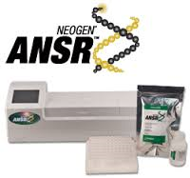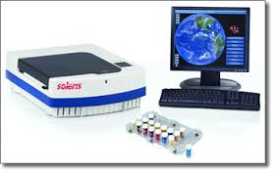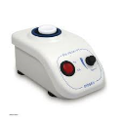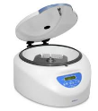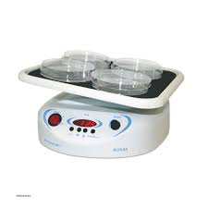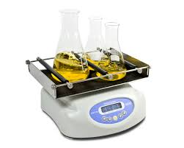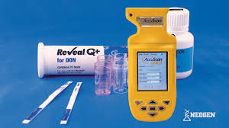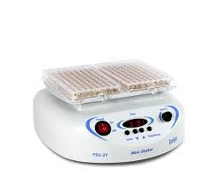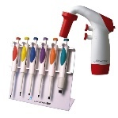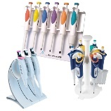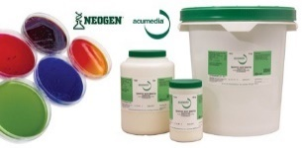Below you can see some of our products:

|  |  |
| --- | --- |
| Accupoint Luminometer (Hygiene Control System) | Accuclean  (Surface Cleaning Control) |
| Stat-Fax 4700 (Multiple Positions Spectrophotometer) | Veratox – Quantitative Determinations  (Allergens, Mycotoxins, Biotoxins, etc) |
| Accuscan Gold (Rapid Mycotoxins Determination and Pathogens Microorganism detection) | Reveal Q+ - Quantitative Determinations (Aflatoxin, Ochratoxin A, DON, ZEA, H-T2) |
| Soleris  (Automatic Rapid Microbial Detection, 32-128 positions) | ANSR (New Generation Pathogens Molecular Detection System) |
| Biosan - Rockers, Shakers, Rotators | Accumax – Pipettes, micro-pipettes, falcons, tips, Laboratory consumables |
| Accumedia (Culture media/substrates) | Calibration of Measuring Instruments |

**CRM & QuEChERS**

In Cyprus laboratory, the production department of Certified Reference Materials (CRMs) is located. They are used for the outputs control of private and public laboratories. Some of the main types of CRM are necessary for the documentation of several determinations such as allergens, heavy metals and mycotoxins. Recent years we have expanded to the production of Critical Laboratory Salts (QuEChERS) for the ideal preparation of samples which makes pesticide residue analysis easier, cheaper, faster and more reliable. Besides the Greek market the above products have been settled through solid partnerships internationally to more than 30 countries like, France, Germany, Switzerland, USA, Japan, Spain, Italy, Canada, Malaysia, Great Britain, Poland, Finland, etc.

|  |  |
| --- | --- |
| **CRMs** (5-100ppm) | **QuEChERS** |
| Gluten, crustaceans, Peanuts, Soybeans, Lactose, Nuts, Eggs, Fish, celery, mustard, sesame, sulfites, Lupine, Mollusks | FAL CMS 2, FAL CMS 2A, FAL CMS 2B  MgSO4, PSA, NaCl, NaAcetate |
| Mycotoxins (Aflatoxins B1, B2, G1, G2, M1 – Ochratoxin A, DON, ZEA, Fumonisin, Patulin) | FAL CMS 3, FAL CMS 3A, FAL CMS 3B  MgSO4, PSA, C18, GCB |
| Minerals (Ca, Mg, P, K, Fe, Mn, Se, Cu)  Heavy Metals(Cd, Pb, As, Hg, Sn, Cr) | FAL CMS 4, FAL CMS 4A, FAL CMS 4B  MgSO4, PSA, NaCl, C18, GCB, TCD, DHSQ |

* Each product is a link to the the relative photo, its composition, quantity, delivery time, etc and inquiry button

**Labelling**

One of the major risk factors in the food trade sector is their label. Government agencies with a view to consumer protection have developed a range of necessary information (marking requirements) that must be displayed on the label. To further safeguard against any misleading indications such information laid down by the legislation should be written in a strictly specific way. Over the years these laws are adapted and / or specialized in terms of the categories of food products. For this reason, ensuring the accuracy of the displayed information in the primary packaging of food products is not easy. Food Allergens Lab having extremely qualified personnel with vast experience in the field (more than 500 labels are checked every year) is able to offer a legal review of the labeling of your product, fast, easy, reliable and affordable.

**Training – Seminars**

The Food Allergens Lab organizing and conducting a wide range of training programs. These seminars are aimed at companies and professionals of the food & beverages sector as well as to individuals who want to broaden their scientific knowledge. The Cypriot laboratory is one of the officially certified vocational training centers (VTC) of the Cyprus Republic.

The trainings organized mainly focuses on the qualification of the food business staff and tailored to the information needs of specific groups and transactions carried out by instructors with extensive professional experience in the field. eg Good Manufacture, Handling and Hygiene Practices, in food enterprises (food industry, foodservice (catering), restaurants, bakeries, clinics, hotels, camps, retail).

|  |
| --- |
| **SEMINARS TOPICS** |
| Food Safety - Additives, toxins, pesticides, heavy metals, microorganisms |
| Allergens - Preventing cross-contamination, supervision and cleaning validation |
| Food Contamination - Revised legal framework and analysis |
| Personal Hygiene – Evaluation of manufacturing equipment gets in contact with food |
| Food Development and innovative products |
| Validation methods. Estimation, uncertainty and correlation with sampling procedure |
| Statistical tools for quality control laboratories |
| Evaluation, acceptance and calibration of laboratory equipment |
| Training of internal auditors for quality management systems |
| Addressing GMPs & GHPs problems. Internal Audits |
| Quality control of packaging materials for the food industry |
| Basic training seminars for laboratory staff and application of specialized techniques for analysts |
| Management and Operation of Food Control Laboratory. Methods Accreditation Services. |
| Food Safety System FSSC 22000 |
| HACCP safety system in accordance with the requirements of ISO 22000. |
| Food Certification Systems - BRC (ver.7) & IFS (ver.6), Principles, Requirements and Tests |
| Internal auditors and managers of Food Safety Systems - ISO 22000, BRC, IFS |
| Suppliers Evaluation and effective risk management – On-site Checks |
| Labelling and Food Law (EU, US, China, UAE) - Practical Requirements Interpretation |
| Crisis management and food safety |
| Food Microbiology (Sampling, Classical and new rapid methods) |
| Evaluation of laboratory methods and estimation of measurement uncertainty workshop |
| Sensory evaluation of foods - Requirements, methods and testers verification |
| Food adulteration and Management Methods (olive oil, wine, honey, milk, coffee, tea, etc.) |

**Food Legislation Services, Research and Development (R & D)**

With active members in several International and European Commission organizations Food Allergens Lab is in the heart of the legislation development, giving you continuous and reliable information and guidance. Besides labeling control we undertake the creation and filing of marketing authorization dossiers products and permitivity clarifications on the use of health claims and nutrition. In the same context we provide food safety inspections first and second part but also guidance in obtaining commercial symbols. Finally, in cooperation with food enterprises and research institutions we are involved in the implementation of research activities, with or without participation in sponsored international programs.

**4. NEWS & ACTIVITIES**

**News**

The Food Allergens Laboratory team is multidimensional and constantly updated and informed about the latest developments in the food industry through the participation in a wide range of research and other related groups and activities. Thus, every week we proceed to the publication of informative news bulletin (newsletter) to our entire mailing list.

*Those interested can* [*SUBSCRIBE TO OUR NEWSLETTER*](http://eepurl.com/bcBotv)*by clicking this link.*

**Activities**

In the near future our laboratory will participate in the following shows and exhibitions:

* **POLAGRA Food**, International trade fair – Pozna, 26-29 September 2016
* 4ο Greek Dairy & Cheese Festival – S.P.F, 14-16 October 2016
* **SIAL** International food exhibition - Paris, 16-20 October 2016
* Olive Oil Festival - Warsaw, 28-29 October 2016
* **Fruit Logisitica** - Berlin, 8-10 February 2017
* **Artoza** International trade fair for Bakery & Patisserie – Athens, 3-6 March 2017
* **Food Expo** – Athens Metropolitan Expo, 18-20 March 2017
* **Anuga** Food Fair - Cologne, 11-15 October 2017

**National and International Research Projects**

The Food Allergens laboratories are constantly seeking to develop new methods and expertise in food and beverages sector. In these terms we have already successfully completed 14 research projects in collaboration with leading research institutes and EU institutions.

1. **EUREKA INTERSTATE GREECE-SPAIN** (EIE - National Research Foundation of Greece)

΄΄ Detection and identification of the Koroneiki variety (Olea Europea var. Microcarpa alba), on samples of extra virgin olive oil.΄΄

1. **INTERSTATE GREECE-SPAIN-ITALY** (ΕΤΑΤ - Research and Technological Development Food Industry)

΄΄International EQUAL Project in Food Section΄΄

1. **ΠΑΒΕΤ ΝΕ** (University of Athens Medical School)

΄΄ Detection of Allergens in patients with unexplained clinical manifestations of food allergy.΄΄

1. **INTERSTATE GREECE-CYPRUS** (Mediterranean Agronomic Institute of Chania & GSL of Cyprus)

΄΄ Development of molecular biological method for assaying protein allergen sesame food.΄΄

1. **INTERSTATE CYPRUS-ROMANIA** (GSL of Cyprus & University of Bucharest)

΄΄ Development of immunochemical detection method for Allergens and Antioxidants in Wines.΄΄

1. **INNOVATION VOUCHER** (Agricultural University of Athens)

΄΄ Determination of Polyphenols and Fat-soluble vitamins in oils.΄΄

1. **ARCHIMEDES** (Catholic University of Portugal, TEI Athens)

΄΄ Determination of vitamins and trace elements in Greek and Portuguese Cheeses.΄΄

1. **RESEARCH PROMOTION FOUNDATION** (University of Nicosia & Pittas Dairy)

΄΄Identification of different types of milk added in Halloumi with specialized molecular techniques RT-PCR.΄΄

1. **RESEARCH PROMOTION FOUNDATION** (GSL of Cyprus, Agricultural University of Athens, ΤΕΙ of Thessaloniki, University of Wienne)

΄΄ Developing of an innovative product: Gluten-free bread.΄΄

1. **SEE-ERA.NET PLUS** (NAGREF-GR, IMPR-SER, UKIM-FYR, FAZ-CRO)

΄΄ Conservation and Sustainable Exploitation of indigenous Medicinal and Aromatic plants traditionally used in the SEE, WB countries. A model approach for Sideritis spp. (Mountain tea).΄΄

1. **BUSSINES PRODUCT** (GSL of Cyprus & Open University of Nicosia)

΄΄ Ανάπτυξη Μεθόδων Ανίχνευσης Αλλεργιογόνων με Ανοσοχημικές και Μοριακές Τεχνικές.΄΄

1. **EMPLOYMENT** (Food Allergens Laboratory)

΄΄ Development of Allergen Detection Methods with Immunochemical and Molecular Techniques.΄΄

1. **AURORA** (NCSR Demokritos, H&S Technology Solutions SA, Theta Metrisis SA, Provirom Ltd)

΄΄Ολοκληρωμένη Οπτοηλεκτρονική Πλατφόρμα Πυριτίου Υπερυψηλής Ευαισθησίας για Επιτόπιες Περιβαλλοντολογικές Αναλύσεις.΄΄

1. **MARS FP7** (INRA-FR, UMIL-IT, UNIBO-IT, USAMVB-RO, FGI-BU, MKU-TUR, NAGREF-GR, CSIC-ESP, MENDELU-CZE, ADNID-FR, CEPIS-FR, CRPV-IT, BETA-TUR, JUGLANS-BU, EFEVDSSL-ESP, KAR.I.F-GR)

΄΄ Marker Assisted Resistance to Sharka.΄΄

**Textbooks & Publications in International Scientific Journals**

Executives of our company have plenty of publications in scientific journals and publications of scientific literature. Indicatively, some of them:

Title: ‘’**Food Allergen Testing: Molecular, Immunochemical and Chromatographic Techniques’’**

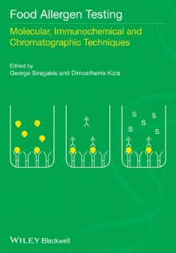Editors: **George Seiragakis,** Dimosthenis Kizis

Contibutors: J.A. Rice, A.J. Lupo, T. Lau, **M. Christofakis**, A. Xila, K. Rizou, A.Bartos, J. Leszcynska, I. Majak, R. Kokkinofta, **A. Lampidonis,** S. Tomoskozi, K. Torok, Z. Bugyi, L. Hajas, Ch. Alexopoulos, E. Kakoulides, E. Lampi.

Publisher: Wiley-Blackwell, Feb **2014**

ISBN: 978-1-118-51920-2

****Title: ‘’**Food Allergens: Analysis, Instrumentation and Methods’’**

Editors:Leo M.L. Nollet, Arjon J. van Hengel

Contibutors: P.E. Johnson, A.I. Sancho, R.W. Crevel, E.C. Mills, C. Faeste, T. Holzhauser, M. Roder, M. Steinhoff, A. Paschke-Kratzin, **G. Seiragakis**, D. Kizis, P.W. Lee, S. Taylor.

Publisher: CRC Press Taylor & Francis Group, Dec **2010**

ISBN: 978-1-439-81503-8

**G.E. Miliadis**, P. Malatou, P. Tsiantas, A. Vrettakou, V.I. Evangelou, Ch. Anagnostopoulos, **G. Seiragakis** - Carryover effect in pesticide residues analysis by LC-MS/MS, Hellenic Veterinary Medical Society Journal – In press

Dimitra Tsantaki · **G. Seiragakis** - An EU health claim for olive oil polyphenols, New Food magazine – 19(1):17 · Feb 2016

Myers et al. - ''AOAC SMPR® 2016.004 Standard Method Performance Requirements for Quantitative Measurement of β-Cryptoxanthin, Lutein, and Zeaxanthin in Ingredients and Dietary Supplements, FAL-CRMs'', – Journal of AOAC International, (99):4, 1105 Aug 2016

G. Theodorou · G. Papadomichelakis · E. Tsiplakou · **A. D. Lampidonis** · S. Chadio · G. Zervas · I. Politis - Effects of soyabean meal - or whey-based diets on lipid metabolism in weaned piglets - Journal of Animal Physiology and Animal Nutrition 99(1):92 · Jun 2014

C. Anagnostopoulos · K. Liapis · S. Haroutounian · **G.E. Miliadis** - Development of an Easy Multiresidue Method for Fat-Soluble Pesticides in Animal Products Using Gas Chromatography Tandem Mass Spectrometry - Food Analytical Methods 7(1):205, · Jan 2014

**Evangelou V**., Bouga M., Emmanouel N, Perdikis D., Papadoulis G. - Discrimination of two natural biocontrol agents in the Mediterranean region based on mitochondrial DNA sequencing data - Biochemistry Genetics 51(11-12):825 · Dec 2013

C. Anagnostopoulos **· G.E. Miliadis** - Development and validation of an easy multiresidue method for the determination of multiclass pesticide residues using GC-MS/MS and LC-MS/MS in olive oil and olives - Talanta 112(3):1, · Aug 2013

C. Anagnostopoulos · A. Bourmpopoulou · **G.E. Miliadis** - Development and Validation of a Dispersive Solid Phase Extraction Liquid Chromatography Mass Spectrometry Method with Electrospray Ionization for the Determination of Multiclass Pesticides and Metabolites in Meat and Milk - Analytical Letters 46(16): 2526, · Jun 2013

M. Metsoviti, **K. Paraskevaidi**, A. Koutinas, A.P. Zeng, S. Papanikolaou - Production of 1,3-propanediol, 2,3-butanediol and ethanol by a newly isolated Klebsiella oxytoca strain growing on biodiesel-derived glycerol based media - Process Biochemistry – 47(12):1872 · Dec 2012

E. Bempelou · K. Liapis · **G.E. Miliadis** - Validation of single residue methods for the determination of dithiocarbamates and inorganic bromide residues in plant products - Hellenic Plant Protection Journal - 5(2): 57, · Jul 2012

E.Touloupakis · R.Gessman · K. Kavelaki · **E.Christofakis** · K. Petratos · D.F. Ghanotakis – Isolation, characterization, sequencing and crystal structure of charybdin, a type I ribosome inactivating protein from Charybdis maritima agg. - FEBS Journal - 273(12): 2684, · Jun 2012

C. J. Anagnostopoulos · G. Balagiannis · **G.E. Miliadis** - Comparison of Liquid and Gas Chromatographic Mass Spectrometry for the Determination of Multiclass Pesticides at Low Concentrations - Spectroscopy Letters - 45(3):202 · Apr 2012

I. Politis · G. Theodorou · **A.D. Lampidonis** · A. Kominakis · A. Baldi - Short communication: Oxidative status and incidence of mastitis relative to blood α-tocopherol concentrations in the postpartum period in dairy cows - Journal of Dairy Science 95(12):7331 · Dec 2012

**G. Seiragakis** · **M. Christofakis** · E. Maistrou - Profile of Tocopherols in Greek Olives and Olive Oils, Annals of Nutrition and Metabolism - 60(2):143, · Jan 2012

F. Hatjina, G. Tsoktouridis, M. Bougac, L. Charistos, **V. Evangelou**, D. Avtzis, I. Meeuse, M. Brunain, G. Smagghe, D.C. de Graaf - Polar tube protein gene diversity among Nosema ceranae strains derived from a Greek honey bee health study – Journal of Invertebrate Pathology 108(2):131 · Oct 2011

Bouga M., **Evangelou V.**, Lykoudis D., Cakmak I., Hatjina F. - Genetic structure of Marchalina hellenica (Hemiptera: Margarodidae) populations from Turkey: preliminary mtDNA sequencing data - Biochemistry Genetics 49(11-12):683 · Dec 2011

Ch. Anagnostopoulos · P. Sarli · K. Liapis · S. Haroutounian · **G.E. Miliadis** - Validation of Two Variations of the QuEChERS Method for the Determination of Multiclass Pesticide Residues in Cereal-Based Infant Foods by LC–MS/MS - Food Analytical Methods 5(4): 664, · Aug 2011

Savvatianos S.· Giavi S. · Stefanaki E. · **Seiragakis G.** · Manousakis E. · Papadopoulos N.G. - Cow’s milk allergens as an infrequent cause of anaphylaxis to systemic corticosteroids - Clinical and Transl Allergy 1(1):18, · Feb 2011

Vassilopoulou E. · Karathanos A. · **Seiragakis G**. · Giavi S. · Sinaniotis A. · Douladiris N. · Fernandez-Rivas M. · Clausen M. · Papadopoulos N.G. - Risk of allergic reactions to wine, in milk, egg and fish-allergic patients - Clin Transl Allergy. 1(1):10, · Oct 2011

I. Politis · G. Theodorou · **A.D. Lampidonis** · R. Chronopoulou · A. Baldi - Soya protein hydrolysates modify the expression of various pro-inflammatory genes induced by fatty acids in ovine phagocytes - The British journal of nutrition – 108(7):1246 · Dec 2011

**A.D. Lampidonis** · G Theodorou · C Pecorini · R Rebucci · A Baldi · I Politis - Cloning of the 5 ' regulatory regions and functional characterization of the core promoters of ovine PLAU (u-PA) and SERPIN1 (PAI-1) – Gene 489(1):11 – Sept 11

G Theodorou · **A.D. Lampidonis** · G P Laliotis · I Bizelis · I Politis - Expression of plasminogen activator-related genes in the adipose tissue of lactating dairy sheep in the early post-weaning period - Journal of Animal Physiology and Animal Nutrition 96(3):403 · May 2011

**A.D. Lampidonis** · E. Rogdakis · G. Voutsinas · D.J. Stravopodis - The resurgence of Hormone-Sensitive Lipase (HSL) in mammalian lipolysis -  Gene 477(1-2):1 · May 2011

N. Vlastaras · E. Dasenakis · K.S. Liapis · **G.E. Miliadis** · C. Anagnostopoulos - Validation of a multiresidue method for the determination of multiclass pesticides by using representative analytes by gas chromatography - Hellenic Plant Protection Journal 3(2):57, · Jul 2010

C. Anagnostopoulos · P.Sarli · **G.E. Miliadis** · C. Haroutounian - Validation of the QuEChERS method for the determination of 25 priority pesticide residues in cereal-based baby foods by gas chromatography with electron capture and nitrogen phosphorous detection - Plant Protection Journal 3(2):71, · Jul 2010

K. Flampouri · S. Mavrikou · S. Kintzios · **G.E. Miliadis** · P. Sarlis - Development and validation of a cellular biosensor detecting pesticide residues in tomatoes - Talanta 80(5):1799 · Mar 2010

C. Anagnostopoulos · **G.E. Miliadis** · K. Liapis · P. Sarlis - A multiresidue method for analysis of 56 pesticides in peaches using liquid chromatography with tandem mass spectrometry detection - Hellenic Plant Protection Journal 2(2):75 · Jul 2009

C. Anagnostopoulos · **G.E. Miliadis** - Method validation for the determination of pesticide residues in wheat flour by gas chromatography - Hellenic Plant Protection Journal 2(1): 15 · Jan 2009

D. Stravopodis · P. Karkoulis · E. Konstantakou · S. Melachroinou · **A.D. Lampidonis** · D. Anastasiou · S. Kachrilas · N. Messini-Nikolaki · I. Papassideri · G. Aravantinos · L. Margaritis · G. Voutsinas - Grade dependent effects on cell cycle progression and apoptosis in response to doxorubicin in human bladder cancer cell lines - International Journal of Oncology 34(1):137 · Feb 2009

G. Stefos · W. Becker · **A.D. Lampidonis** · E. Rogdakis - Cloning and functional characterization of the ovine malic enzyme promoter - Gene 428(1-2):36 · Nov 2008

**A.D. Lampidonis** · D. Stravopodis · G. Voutsinas · N. Nikolaki · G. Stefos · L. Margaritis · A. Argyrokastritis · I. Bizelis · E. Rogdakis - Cloning and functional characterization of the 5 ' regulatory region of ovine Hormone Sensitive Lipase (HSL) gene - Gene 427(1-2):65 · Oct 2008

**G.Siragakis · E. Christofakis** – Pathogens in Food by PCR. A case study: Campylobacter in Poultry – BIO Journal 26(51):51 · Sept 2008

**A.D. Lampidonis** · A. Argyrokastritis · D. Stravopodis · G. Voutsinas · T. Ntouroupi · L. Margaritis · I. Bizelis · E. Rogdakis - Cloning and functional characterization of the ovine Hormone Sensitive Lipase (HSL) full-length cDNAs: An integrated approach - Gene 416(1-2):30 · Jul 2008

P. Dais · A. Spyros · S. Christophoridou · E. Hatzakis · G. Fragaki · A. Agiomyrgianaki · E. Salivaras · **G. Seiragakis** · D. Daskalaki · M. Tasioula-Margari · M. Brenes - Comparison of analytical methodologies based on 1H and 31P NMR spectroscopy with conventional methods of analysis for the determination of some olive oil constituents - J. Agric. Food Chem., 55(1):577 · Apr 2007

D.T. Likas · N.G. Tsiropoulos · **G.E. Miliadis** - Rapid gas chromatographic method for the determination of famoxadone, trifloxystrobin and fenhexamid residues in tomato, grape and wine samples - J Chromaogr - 1150(12):208 · May 2007

Ch. Anagnostopoulos · **G.E. Miliadis** · P. Sarlis · B. Ziogas - Comparison of external and internal standard methods in pesticide residue determinations - International Journal of Environmental Analytical Chemistry - 86(1):77 · Jan 2006

P. Georgiou · K. Liapis · **G.E. Miliadis** · P. Siskos - Solidphase extraction cleanup of tomato samples for the determination of pesticide residues by gas chromatography-electron capture detection - International Journal of Environmental Analytical Chemistry - 86(1):69 · Jan 2006

N.G. Tsiropoulos · **G.E. Miliadis** · D. Likas · K. Liapis - Residues of Spiroxamine in Grapes Following Field Application and Their Fate from Vine to Wine - Journal of Agricultural and Food Chemistry - 53(26):10091 · Jan 2006

K. Antonopoulos · Ν. Valet · D. Spiratos · **G. Seiragakis** - Olive oil and pomace olive oil processing – Grasas Y Acetes 57(1):56 · Sept 2006

N. Papayannakos · C. Rakopoulos · S. Kyritsis · A. Lappas · A. Chatzigakis · G. Chlivinos · I. Liakopoulos · **G. Seiragakis** - Pilot production and testing of bio-diesel produced from greek feedstocks – ECOS 1(12): 1489, · Jul 2006

G. Fragaki · A. Spyros · **G. Seiragakis** · E. Salivaras · P. Dais - Detection of extra virgin olive oil adulteration with lampante olive oil and refined olive oil using NMR spectroscopy and multivariate statistical analysis - J. Agric. Food Chem., 53(1):2810 · Nov 2005

N.G. Tsiropoulos · K. Liapis · D. Likas · **G.E. Miliadis** - Determination of spiroxamine residues in grapes, must, and wine by gas chromatography/ion trap-mass spectrometry - Journal of AOAC International - 88(6):1834 · Nov 2005

**G.E. Miliadis** · K. Liapis · P. Malatou - International Journal of Environmental Analytical Chemistry - 84(1):193 · Jan 2004

P. Sarlis · **G.E. Miliadis** · K. Liapis · N.G. Tsiropoulos - A Gas Chromatographic Determination of Residues of Eleven Insecticides and Two Metabolites on Olive Tree Leaves - Journal of AOAC International 87(1):146 · Jan 2004

Baritaki S., Zafiropoulos A., Sioumpara M., **Politis M.**, Spandidos D.A., Krambovitis E. - Ionic interaction of the HIV-1 V3 domain with CCR5 and deregulation of T lymphocyte function - Biochemical and Biophysical Research Communications – 298(4):574 · Nov 2002

K.Liapis · **G.E. Miliadis** · N.G. Tsiropoulos - Confirmation of Pesticides in Water Samples by Mass Spectrometry - Bulletin of Environmental Contamination and Toxicology - 65(6):811 · Jan 2001

P. Falaras · F. Lezou · **G. Seiragakis** · D. Petrakis - Bleaching properties of alumina-pillared acid-activated montmorillonite - Clays and Clay Minerals 48(5):549, · Oct 2000

P. Falaras · I. Kovanis · F. Lezou · **G. Seiragakis** - Cottonseed oil bleaching by acid-activated montmorillonite - Clay and Clay Minerals 34(2):221, · Jun 1999

N.G. Tsiropoulos · P. Sarlis · **G.E. Miliadis** - Evaluation of Teflubenzuron Residue Levels in Grapes Exposed to Field Treatments and in the Must and Wine Produced from Them -  Journal of Agricultural and Food Chemistry 47(11):4583 · Dec 1999

P. Sarlis · **G.E. Miliadis** · N.G. Tsiropoulos - Dissipation of Teflubenzuron and Triflumuron Residues in Field-Sprayed and Cold-Stored Pears - Journal of Agricultural and Food Chemistry 47(7):2926 · Aug 1999

**G.E. Miliadis** · N.G. Tsiropoulos · P. Sarlis - High-performance liquid chromatographic determination of benzoylurea insecticides residues in grapes and wine using liquid and solid-phase extraction - Journal of Chromatography A 835(1):113 · Apr 1999

N.G. Tsiropoulos · P.G. Aplada-Sarlis · **G.E. Miliadis** - Determination of benzoylurea insecticides in apples and pears by solid-phase extraction cleanup and liquid chromatography with UV detection - Journal of

AOAC International 82(1):213 · Jan 1999

**G.E. Miliadis** · P. Malatou - Analysis of Pesticide Residues in Vegetables by Gas Capillary Chromatography - International Journal of Environmental Analytical Chemistry 70(1):29 · May 1998

N.G. Tsiropoulos · **G.E. Miliadis** - Field Persistence Studies on Pendimethalin Residues in Onions and Soil after Herbicide Postemergence Application in Onion Cultivation - Journal of Agricultural and Food Chemistry - 46(1):291, · Feb 1998

**G.E. Miliadis** · P.A. Sarlis · K. Liapis - Disappearance of Tetradifon from Field-Sprayed Apricots and the Apricot Juice Produced from Them - Journal of Agricultural and Food Chemistry 43(6):53 · June 1995

**G.E. Miliadis** · P.A. Sarlis · K. Liapis - Dissipation of pyrazophos residues in greenhouse tomatoes - Bulletin of Environmental Contamination and Toxicology 53(6):883 · Jan 1995

K. Liapis · **G.E. Miliadis** · P.A. Sarlis - Persistence of monocrotophos residues in greenhouse tomatoes - Bulletin of Environmental Contamination and Toxicology 53(2):303 · Sept 1994

P.A. Sarlis · K. Liapis · **G.E. Miliadis** - Study of Procymidone and Propargite Residue Levels Resulting from Application to Greenhouse Tomatoes - Journal of Agricultural and Food Chemistry 42(7):1575 · Jul 1994

P.A. Sarlis · K. Liapis · **G.E. Miliadis** - Contamination of potato tubers and carrots in Greece with Lindane residues - Bulletin of Environmental Contamination and Toxicology 52(1):135 · Feb 1994

**G.E. Miliadis** - Determination of pesticide residues in natural waters of Greece by solid phase extraction and gas chromatography - Bulletin of Environmental Contamination and Toxicology 52(1):25 · Jan 1994

**G.E. Miliadis** · K. Liapis - Determination of arsenic residues in agricultural products of Milos island - Analytica Chimica Acta 283(1):258 · Nov 1993

**G.E. Miliadis** - Gas chromatographic determination of pesticides in natural waters of Greece - Bulletin of Environmental Contamination and Toxicology 50(2):247 · Mar 1993

P.G. Patsakos · K. Liapis · **G.E. Miliadis** · K. Zafiriou - Mancozeb residues on field sprayed apricots - Bulletin of Environmental Contamination and Toxicology 48(5):756 · Jun 1992

**G.E. Miliadis** · P. Siskos · G. Vasilikiotis - Simplified cleanup and liquid chromatographic ultraviolet determination of linuron and three metabolites in potatoes - Journal of AOAC Int. 73(3):435 · May 1990

**Invited speakers at Conferences, Seminars and Workshops**

11th European Pesticide Residue Workshop, Limassol **2016**

‘’Problems encountered in LC-MC/MS analysis for the determination of pesticide residues in food: solvent, matrix and carry over effects’’, **G.E. Miliadis**

1st International Conference BACiF – Lodz, **2015**

‘’Food Allergens Testing by Elisa & LC-MS/MS Techniques’’, **G.Seiragakis**

2nd EFSA’s Scientific Conference, ‘’Shaping the future of Food Safety, Together’’ – Milan **2015**

‘’The importance of inspection in food safety assurance systems’’, **A.Varlamos**

2nd Farmer Expo Hellas, MEC – Athens **2015**

‘’Agricultural Products Exports: Olive Oil Innovations, Honey Problems & Prospects’’, **FAL Panel**

1st Farmer Expo Hellas, MEC – Athens **2014**

‘’Agricultural Products Imports from 3rd Countries: Pesticides Residues Testing Methods’’, **FAL Panel**

2nd Annual World Congress on Food Science and Technology – Hangzhou **2013**

‘’Food Allergens by Immunoasay, PCR & Chromatography BITs’’, **G.Seiragakis**

2nd European Conference on Crop Protection, Hungry for Change, Brussels **2013**

‘’Feedback on the presentation from the laboratory and consumer perspective and key points on the main challenges in the area of pesticide residues in food’’, **A.Varlamos**

Food Allergies and European Regulation 1169/2011,

**A.Varlamos** - Workshop in cooperation with the company Theodorou Automation, Athens **2013**

Aromatic & medicinal plants crops in Greece

**A.Varlamos** – Report/presentation within the Elaiotechnia exhibition show, Athens **2012**

3rd MoniQA Congress – Varna **2011**

‘’Determination of Allergens and Mycotoxins by ELISA spectrophotometric method’’, **G.Seiragakis**

2nd Congress of the European Alliance Health Allegations (EHCI), In Search of Solutions - Brussels, **2010**

‘’A stakeholder dialogue on Art.13 Health Claim’’, **A. Varlamos**

BEUC view on DG Sanco Priorities within the next 5 years

**A.Varlamos** - DG SANCO Advisory Group - Brussels, **2010**

11th Globalgap Tour Conference – Food Against Consumers, Athens **2009**

‘’Food Analysis for residues of pesticides: current situation, challenges and perspectives’’, **G.E. Miliadis**

3rd Olivebioteq Int. Conference, Renovated Mediterranean Olive Growing Sector – Sfax Tunis, **2009**

‘’Olive oil detection in special feedstuffs’’, **G.Seiragakis**

Investigating the consumer perception system on emerging technologies in the food area ILSI Workshop, **A.Varlamos** - Emerging Technologies for Efficacy Demonstration – Brussels **2009**

16th Greek Chemist’s Congress Food Chemistry Days, Food and Environment – Athens **2009**

‘’Plant Pesticides Products, Legislation limits and Modern Analytical Techniques’’, **G.E. Miliadis**

1st International Conference on Biotechnology for the Wellness Industry – Kuala Lumpur **2008**

‘’Olive Oil quality parameters and methods of testing’’, **G.Seiragakis**

14th Congress of Greek Chemist Organization – Athens 2007

‘’Pesticides Residue Testing in Food and Food Products’’, **G.E. Miliadis**

1st Conference on Quality and Safety meeting ISO 22000:2005 – Athens **2006**

‘’Pesticide residues in food’’, **G.E. Miliadis**

3rd European Conference on pesticides and related organic micropollutants – Chalkidiki **2004**

‘’Accreditation of pesticide residues laboratories by E.SY.D.’’, **G.E. Miliadis**

4th Intenational Congress of Clinical Oncology – Patra **2004**

‘’Agricultural products testing for determine pesticide residues", **G.E. Miliadis**

3rd International Congress - Quality Forum – Athens **2003**

‘’Food and water controls on pesticide residues’’, **G.E. Miliadis**

2nd European Conference on pesticides and relative organic micropollutants – Corfu **2002**

‘’Assessment of the performance of 11 Greek laboratories through a proficiency test on the analysis of grapes for the determination of pesticides residues", **G.E. Miliadis**

18th National Conference of Chemistry – Piraeus **2001**

‘’Analysis of agricultural products and water to detect and identify pesticide residues concentration: methodology and current situation in Greece’’, **G.E. Miliadis**

1st European Conference on pesticides and relative organic micropollutants – Ioannina **2001**

‘’Pesticides residues in the environment - methodology in compliance with the European Union legislation’’, **G.E. Miliadis**

3rd National Conference Greek Society of Nutrition and Food – Thessaloniki **1998**

‘’Pesticide residues and food - water safety’’, **G.E. Miliadis**

1st National Meeting on Plant Protection – Larissa **1996**

‘’Pesticide residues in agricultural products and surface waters in Greece’’, **G.E. Miliadis**

**Presentations in National and International Conferences**

5th International Congress Food from A to Z, Lodz **2016**

‘’Rapid methods of analysis for the dairy sector’’, **A. Abrozniak, G.Seiragakis**

6th Ordinary Congress of Metrology, Athens **2016**

‘’Determination of Mycotoxins in cereals by LC-MS triple quadrupole’’, **P.Tsiantas, G.E. Miliadis**

‘’Problems in Food Analysis using LC-MS triple quadrupole’’, **G.E. Miliadis, P.Tsiantas, G.Seiragakis**

‘’Carryover effect in Pesticides Analysis by LC-MS/MS’’, **V.Evagelou**, H.Anagnosotpoulos, **G.E. Miliadis**

11th European Pesticide Residue Workshop, Limassol **2016**

‘’Problems encountered in LC-MC/MS analysis for the determination of pesticide residues in food: solvent, matrix and carry over effects’’, **G.E. Miliadis**

1st International Conference BACiF – Lodz, **2015**

‘’Food Allergens Testing by Elisa & LC-MS/MS Techniques’’, **G.Seiragakis**

2nd EFSA’s Scientific Conference, ‘’Shaping the future of Food Safety, Together’’ – Milan **2015**

‘’The importance of inspection in food safety assurance systems’’, **A.Varlamos**

27th National Congress in Fruits & Vegetables Science – Volos, **2015**

‘‘Pesticides determination in fruits & vegetables with LC-MS/MS’’, **P.Tsiantas, G.Seiragakis, G.Miliadis**

6th Greek Lipid Forum, NIR – Athens, **2015**

‘’Determination of Aflatoxins in Greek vegetable oils’’, **P.Tsiantas, F.Spithouraki, G.Seiragakis**

7th International Symposium IDF – Limassol, **2015**

‘’Food Allergens in Traditional Dairy Products of Cyprus’’, **G.Seiragakis**

1st National Quality Conference – Athens, **2014**

‘’Food Standardization & Customer Satisfaction’’, **A.Varlamos**

6th Olivebioteq International Conference –Amman Jordan, **2014**

‘’Reduction of acrylamide in potato chips using olive oil as frying mean. Immunoassay vs LC-MS/MS techniques for acrylamide determination’’, **G. Seiragakis, G.E. Miliadis**

5th Greek National Metrology Conference - At NAGRIEF, Athens Greece, **2014**

‘’Salmonella & Listeria Detection by molecular techniques’’, **G. Seiragakis, A.D. Lampidonis**

8th Conference in pesticides and related organic micropollutants in the environment – Ioannina, **2014**

‘‘A new method for the simultaneous detrmination of 219 pesticides and 13 non dioxin like PCBs in water using LC-MS/MS and GC/MS(n) systems’’, A. C. Charalampous, **G.E. Miliadis**, M. A. Koupparis

‘’Determination of acrylamide in low and high fat content food by different variations of the Quechers method’’, A. Vrettakou, **G. Miliadis, G. Siragakis**

2nd European Conference on Crop Protection, Hungry for Change, Brussels **2013**

‘’Feedback on the presentation from the laboratory and consumer perspective and key points on the main challenges in the area of pesticide residues in food’’, **A.Varlamos**

EFSA EU Regulation Framework – Brussels **2013**

‘’Risk-Benefits considerations in the area of botanicals’’, **A.Varlamos**

2nd Annual World Congress on Food Science and Technology – Hangzhou **2013**

‘’Food Allergens by Immunoasay, PCR & Chromatography BITs’’, **G.Seiragakis**

4th National Conference on ‘’Biotechnology and Food Technology‘’ – Athens, **2013**

‘’Molecular Techniques in Food Safety and Quality’’, ‘’Use of Greek Plants for the Reduction of Pathogens levels in Meat and Meat Products’’, ‘’Detection of Foodborne Pathogens with the use of Molecular Techniques (RT-PCR)’’, **A.D. Lampidonis, M.Poilitis, V.Evangelou, G.Seiragakis**

15th National Entomological Conference – Kavala, **2013**

‘‘Food, water and pesticide residues’’, **G.E. Miliadis**

3rd Conference on Food Safety, Athens **2012**

‘’Food Consumption & Chemical Occurrence data for dietary exposure assesment’’, **A. Varlamos**

15th International Meeting of Fat Soluble Vitamins – Kalabaka **2012**

‘’ a-tocopherols in Greek olive varietes’’, **G.Seiragakis**

4th Ordinary National Congress of Metrology – Athens, **2012**

‘’Development and validation of a multiresidue pesticides determination method using GC-MS/MS and LC-MS/MS in olive oil’’, H. Anagnostopoulos, **G.E. Miliadis,** G. Foteinopoulou, K. Liapis

‘’Development and validation of the method for the determination of pesticide residues in water by techniques LC-MS/MS and GC-MS/MS’’, A. C. Charalampous**, G.E. Miliadis**, M. A. Koupparis

3rd Joint Workshop of the EURLs, NRLs & OFLs for Pesticide Residues in Food and Feed, Freiburg **2011**

‘’Pesticide residues in vineleaves’’, **G.E. Miliadis**, P. Malatou, D. Vlahos

3rd MoniQA Congress – Varna **2011**

‘’Determination of Allergens and Mycotoxins by ELISA spectrophotometric method’’, **G.Seiragakis**

61st Annual Meeting of the European Association for Animal Production - Heraklion, **2011**

‘’Reproductive characteristics of pig farms in the region of Epirus, Greece’’, **A.D. Lampidonis** et. al.

4th National Food Conference - Thessaloniki, **2011**

‘‘Validation and study uncertainty specialized dithiocarbamate fungicide residues assays and inorganic bromide in vegetable products’’, E. Bebelou, K. Liapis, **G.E. Miliadis**,

‘’Validation of a variation of QuEChERS method for the determination of pesticide residues in the oil using gas chromatography’’, M.Spantidaki, H. Anagnostopoulos, **G.E. Miliadis,** K. Liapis

‘’Development and validation of a rapid and selective residue assay of plant protection products using GC-MS/MS and LC-MS/MS in milk’’, H. Anagnostopoulos, K. Liapis, S. Haroutounian, **G.E. Miliadis**

4th International Congress Biotechnology and Food Technology – Athens, **2010**

‘’Traceability in the Food Industry: Conditions to avoid crisis’’, **G.Seiragakis**

2nd Congress of the European Alliance Health Allegations (EHCI), In Search of Solutions - Brussels, **2010**

‘’A stakeholder dialogue on Art.13 Health Claim’’, **A. Varlamos**

3rd Olivebioteq Int. Conference, Renovated Mediterranean Olive Growing Sector – Sfax Tunis, **2009**

‘’Olive oil detection in special feedstuffs’’, **G.Seiragakis**

11th Globalgap Tour Conference – Food Against Consumers, Athens **2009**

‘’Food Analysis for residues of pesticides: current situation, challenges and perspectives’’, **G.E. Miliadis**

3rd International Congress Biotechnology and Food Technology – Rethymno **2009**

‘’Identification of olive oil to feed enriched with molecular techniques’’, **G. Seiragakis**

16th Greek Chemist’s Congress Food Chemistry Days, Food and Enviroment – Athens **2009**

‘’Plant Pesticides Products, Legislation limits and Modern Analytical Techniques’’, **G.E. Miliadis**

3rd National Food Biotechnology Congress – Athens **2009**

‘’Comparison of ELISA and PCR techniques for the detection of allergens in food’’, M.Kapoti, **E.Politis**

**‘’**Detection of four major pathogens (Bacillus cereus, Salmonella, Campylobacter spp. and Staphylococcus aureus) in their commonly found substrates’’, **M.Christofakis**, D. Kizis, **G. Seiragakis**

‘’Vibrio parahaemolyticus in seafood by RT-PCR’’, D. Kizis, A. Pourikkou, **G. Seiragakis**

1st Mediterranean Summit of World Science Poultry Association – Chalkidiki **2008**

‘’Rapid testing for Campylobacter spp. in poultry, PCR advantages’’, **M.Christofakis, G. Seiragakis**

1st International Conference on Biotechnology for the Wellness Industry – Kuala Lumpur **2008**

‘’Olive Oil quality parameters and methods of testing’’, **G.Seiragakis**

2nd International Lipid Forum Congress – Athens **2007**

‘’Effects of harvesting techniques on PAHs existence in EVOO’’, C. Antoniou & **G.Seiragakis**

3rd International Symposium on Recent Advances in Food Analysis – Prague **2007**

‘’Adulteration of Extra Virgin Olive Oil’’, **G.Seiragakis**

15th Congress of Greek Chemist Organization – Athens 2007

‘’Pesticides Residue Testing in Food and Food Products’’, **G.E. Miliadis**

1st Conference on Quality and Safety meeting ISO 22000:2005 – Athens **2006**

‘’Pesticide residues in food’’, **G.E. Miliadis**

29th International Symposium on Capillary Chromatography - Riva del Garda **2006**

‘’Famoxadone, Trifloxystrobin and Fenhexamide Determination in Agricultural Commodities by Gas Chromatography using NPD, ECD and MS Detector’’, Likas D., Tsiropoulos N.G., Liapis K., **Miliadis G.E.**

3rd European Conference on pesticides and related organic micropollutants – Chalkidiki **2004**

‘’Accreditation of pesticide residues laboratories by E.SY.D.’’, **G.E. Miliadis**

16th International Instrumental Analysis Conference, Modern Trends & Applications, Thessaloniki **2003**

‘’Determination of thiabendazole residues by LC-DAD and fluorescence detection. Μonitoring of thiabendazole residues in potatoes and bananas’’, Sarlis P., Tsiropoulos N.G., Liapis K., **Miliadis G.E.**

4th European Pesticide Residues Workshop: Pesticides in food and drink – Rome **2002**

‘’Determination 34 priority pesticides residues in water samples by GC-MS’’, **G.E. Miliadis**, P.Malatou

**Seminar, Informational Articles & Workshops**

**G. Seiragakis -** ''Nutritional and Health Claims regarding specific ingredients of the extra virgin olive oil: Polyphenols and tocopherols’’, Elaioparagogi 2016 – p.118

**G. Seiragakis -** ''Nutritional and Health Claims regarding specific ingredients of the Cyprus honey: Riboflavin and Manganese '' Cyprus Beekeeping - In press

**V.Evagelou, G. Seiragakis –** ''Carob Honey (locust beans) Qualitative Characteristics and Prospects'', Cyprus Beekeeping - 16 (5):37 · May **2016**

**G. Seiragakis –** ''Laboratory Analysis of Bioactive Ingredients in Packaged Foods for Health-Claims Documentation'', All Pack Hellas - 72 (1):36 · Feb **2016**

Presentation of the Critical Products FAL-QuEChERs within the Fruit Logistica Promo Service Spotlight Int.

**G. Seiragakis** –Fruchthandel Magazine (3):17,Berlin **2016**

Accurate Tests & Laboratory Equipment for Quality Control (FAL QuEChERs & CRMs)

**N. Galanis** – Middle East Food Magazine (3):34, Beirut **2016**

Rapid Microbiological Techniques Using Specialized Equipment,

**Frederic Martinez** – 1st Neogen Europe Workshop on Rapid Food Safety Solutions, Athens **2016**

Laboratory Analysis of Bioactive Components to Health-Claims Documentation

**G. Seiragakis –** Food Chemistry Week (Functional Foods), Athens **2015**

Laboratory honey testing for exports to the EU, U.S.A., Canada, Japan and other third countries,

**G. Seiragakis –** Roundtable on honey exports, Piraeus **2015**

Food Allergies and European Regulation 1169/2011,

**A.Varlamos** - Workshop in cooperation with the company Theodorou Automation, Athens **2013**

Aromatic & medicinal plants crops in Greece

**A.Varlamos** – Report/presentation within the Elaiotechnia exhibition show, Athens **2012**

Identification of Unknown Compounds by Using LC/TOF-MS

**G.E. Miliadis,** Liapis K. – Greek Society for Mass Spectrometry Conference, Αθήνα **2011**

BEUC view on DG Sanco Priorities within the next 5 years

**A.Varlamos** - DG SANCO Advisory Group - Brussels, **2010**

Food Allergens: Typical cases of contamination at the production process.

**G.Seiragakis –** Food Safety Conference, TEI of Athens **2010**

Biofunctional ingredients in Extra Virgin Olive Oil

**G. Seiragakis – Cyprus Food&Drink Magazine (7):34, 2010**

Polycyclic Aromatic Hydrocarbons in Extra Virgin Olive Oil

**G. Seiragakis – Cyprus Food&Drink Magazine (5):25, 2009**

Investigating the consumer perception system on emerging technologies in the food area ILSI Workshop, **A.Varlamos** - Emerging Technologies for Efficacy Demonstration – Brussels **2009**

Rapid Analysis Methods for the detection of allergens, mycotoxins, GMOs and pathogens

**G.Seiragakis** – Seminar in collaboration with the Aristotle University and N.AG.RE.F., Athens **2008**

Sensory Evaluation of Olive Oil

**G.Seiragakis – Elaikosmos Olive Oil World Magazine (1):45, 2008**

Immunochemical Methods for the detection of Adulteration in Olive Oil

**G.Seiragakis – Elaikosmos Olive Oil World Magazine (1):49, 2008**

The Regulation 1881/2006 for maximum chemical contaminants in meat.

**G. Seiragakis – FOOD TECHnology Magazine (3):30, 2007**

Effect of virgin olive oil filtration processes in the presence of various contaminants

**G. Seiragakis,** I.Sarigiannis – Food Chemistry Week - *GCA*, Thessaloniki **2006**

Legislative requirements for allergen labeling to food products.

**G. Seiragakis – All-Pack Magazine (12):34, 2006**

Immunochemical methods for identifying hazelnut oil in olive oil,

**G. Seiragakis – BioFood Magazine (12):110, 2005**

**Exhibitions & Trade Shows**

The Food Allergens Laboratories having in direct interpersonal contact and communication with customers, partners, professionals and other organizations in the food industry, informing you the latest news and developments supporting any relatively concerns.

In addition to the above relations, the company executives involved in several national and international exhibitions in the food industry, to transfer their knowledge and explain their proposals

25th International Fruit and Vegetables Exhibition, ***Fruit Logistica*** BASF – **Berlin**, 2017

26th International Food Show, ***SIAL*** – **Paris**, 2016

3rd ***Olive Oil*** *Festival &* ***Wine*** *Expo* – **Warsaw**, 2016

4th Milk & Cheese Festival, ***Agro Quality*** – **Athens**, 2016

7th International Show ***POLAGRA-TECH*** – **Poznan,** 2016

4th International Expo ***Free From Food*** – **Amsterdam**, 2016

20th International Food & Beverages Exhibition, ***Food Asia*** – **Singapore**, 2016

3rd International Food & Beverages Trade Show ***Food Expo*** – **Athens**, 2016

24th International Fruit and Vegetables Exhibition, ***Fruit Logistica*** BASF – **Berlin**, 2016

20th International Food Expo, ***ANUGA*** – **Cologne**, 2015

9th International Fruit and Vegetables Expo, ***Fruit Attraction*** IFEMA – **Madrid**, 2015

26th International Food Expo, ***GULFOOD*** – **Dubai**, 2015

3rd International Expo ***Free From Food*** – **Barcelona**, 2015

23rd International Fruit and Vegetables Exhibition, ***Fruit Logistica*** BASF – **Berlin**, 2015

1st Mediterranean Expo for Olive and Olive oil, ***Elaiotechnia*** – **Athens**, 2015

7th ***Greek*** Festival for ***Honey*** and Honey products – **Peiraus**, 2015

25th International Food Show, ***SIAL*** – **Paris**, 2014

23rd International Food & Beverages, Machinery & Equipment Expo, ***DETROP*** – **Thessaloniki**, 2014

19th International Food Expo, ***ANUGA*** – **Cologne**, 2013

3rd International Exhibition of Food, Beverages, Bakery and Confectionery ***ARTOZA*** – **Crete**, 2012

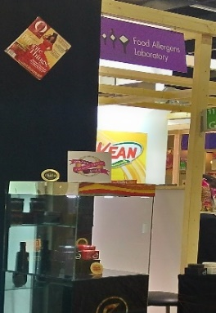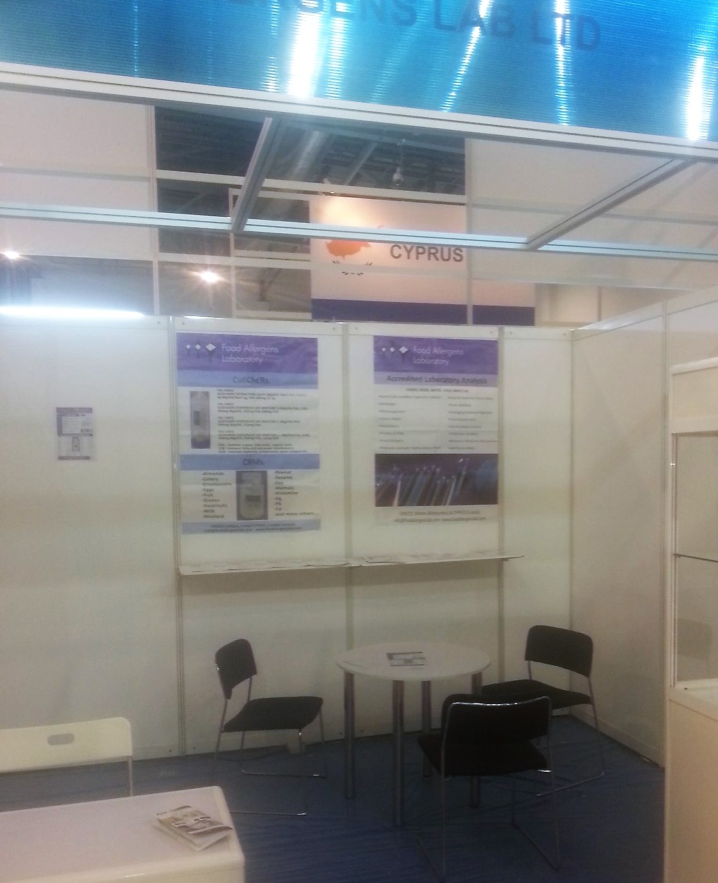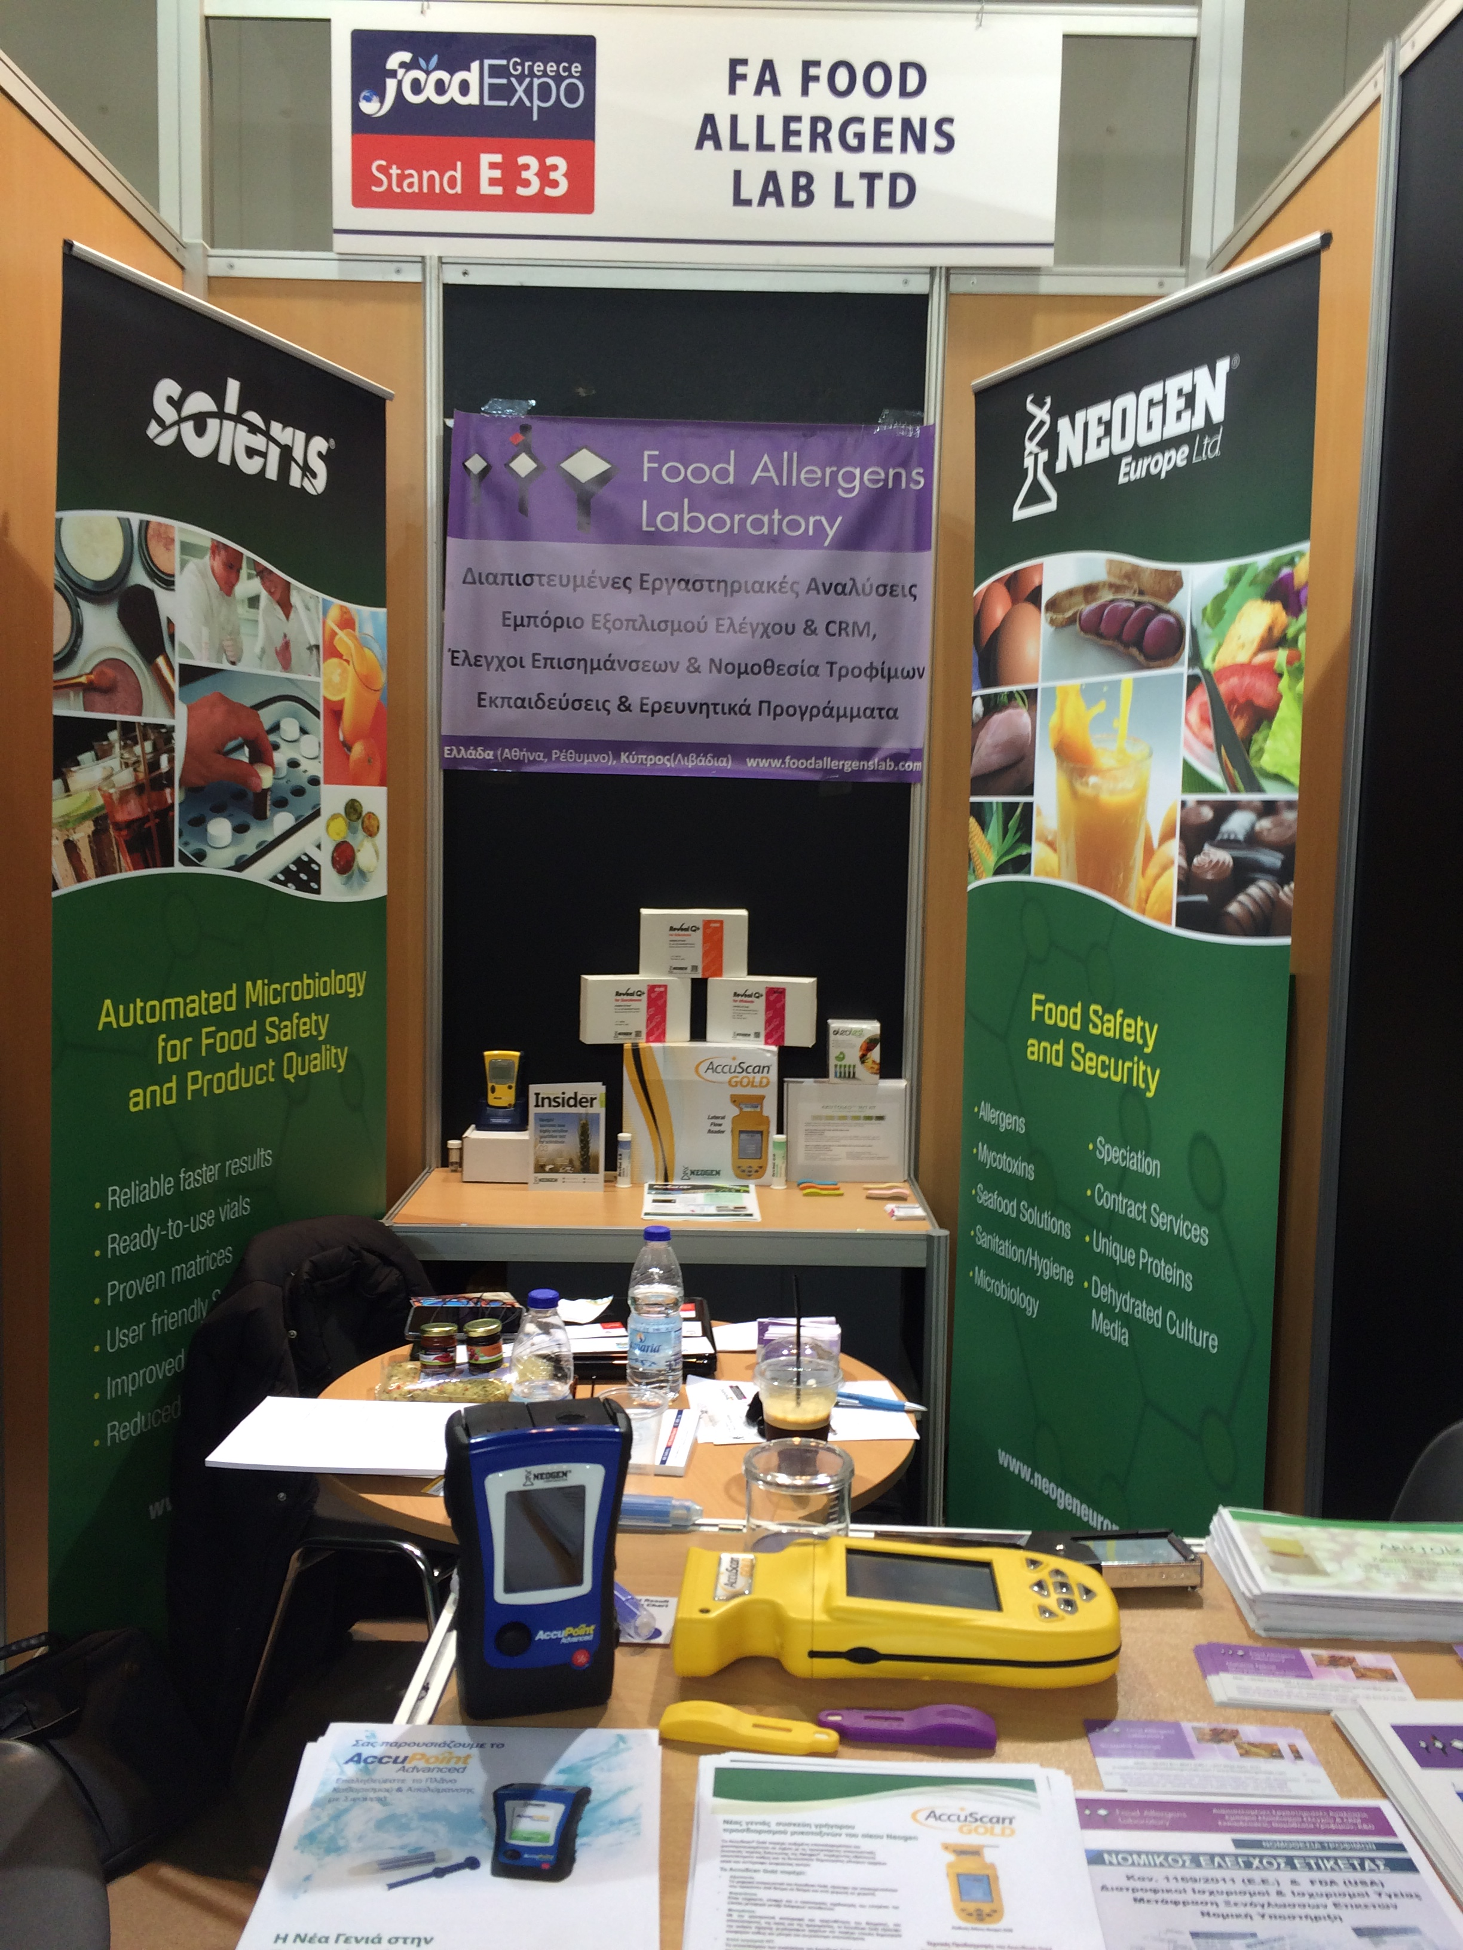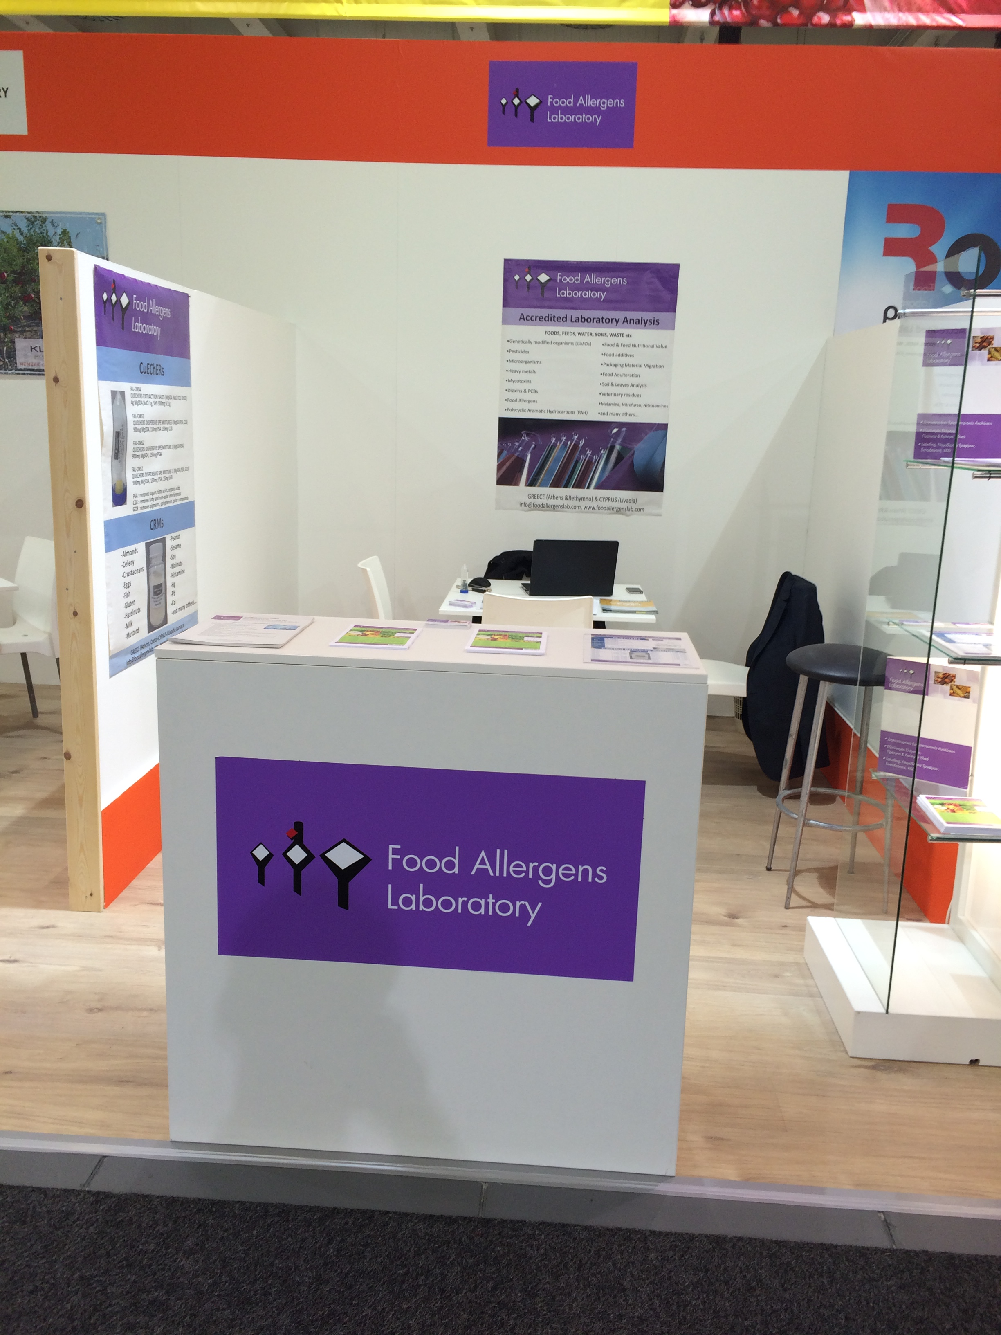

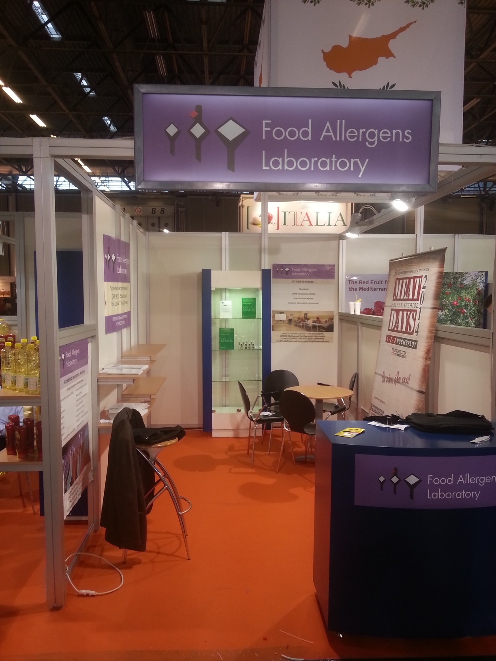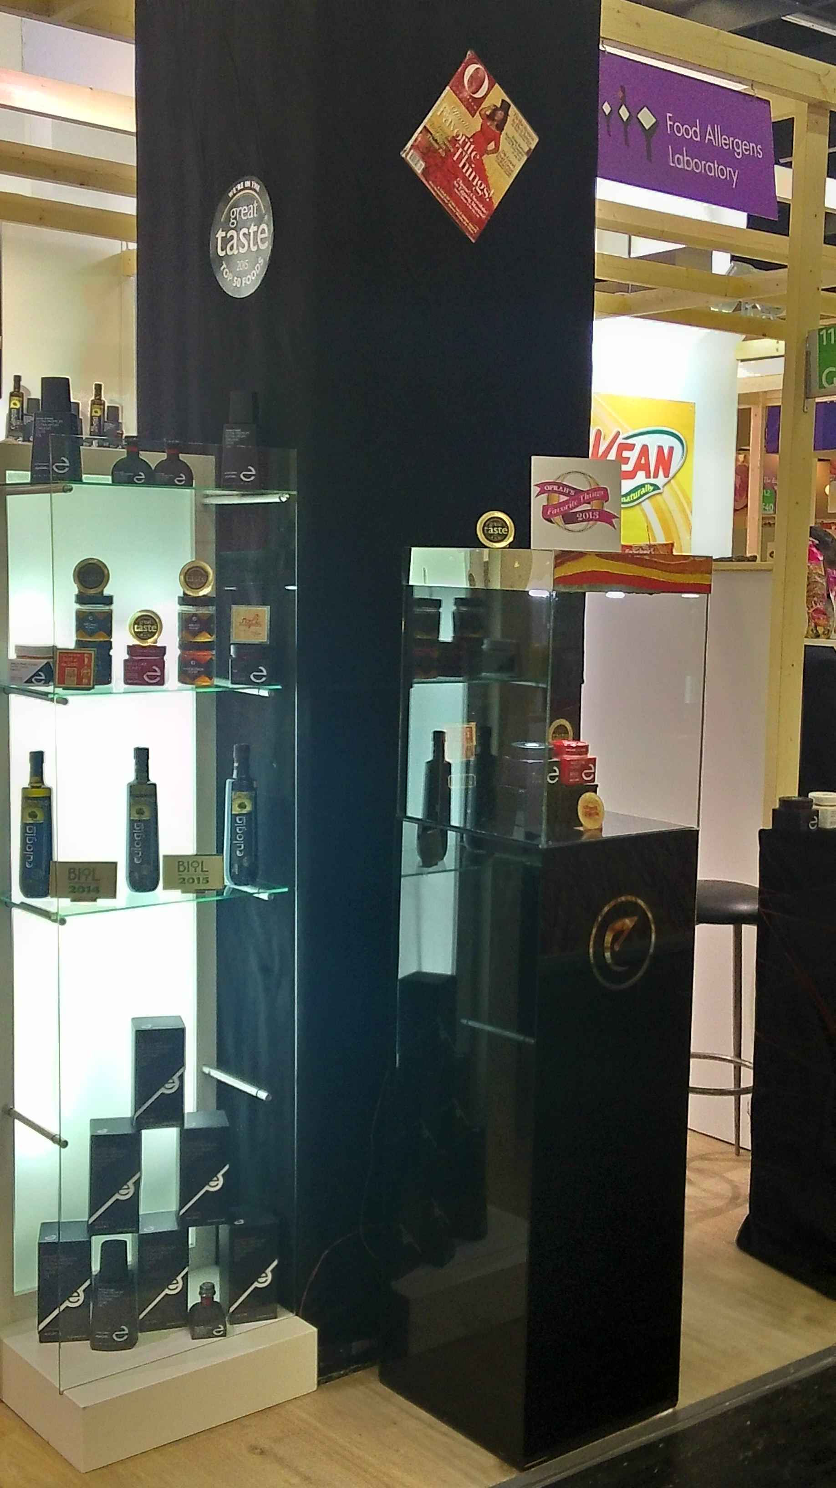

**5. CERTIFICATION, ACCREDITATION, APPROVALS & RECOGNITIONS**

**ISO (International Standard Organization)**

The Food Allergens Laboratories are accredited according to ELOT EN ISO/IEC 17025:2005 standard and the ESYD criteria, to carry out tests as specified in the detailed Scope of Accreditation in several products and substrates based on strictly protocols of different methods. To further ensure the reliability and validity of the results we participate continuously in several interlaboratory proficiency testing schemes (SGL and other laboratories) with very high pass / identification rates of the results. In addition, besides the tests we are certified under ISO 9001: 2008 for the production and trade services of quality control equipment and consumables such as critical materials (FAL-QuEChERS), certified reference materials (FAL-RFMs) and FAL-ELISA kits. The organization of the training courses is also under the requirements of the above standard, offering a perfect consistent and high quality result.

**ESYD (National Accreditation System)**

The certification according to ELOT quality standard EN ISO/IEC 17025: 2005 requires external audits carried out by independent state or other bodies for the maintenance of the whole system reliability. The operation is the so-called accreditation system and the competent authority Greece is the National Accreditation System (ESYD). The official scope of accreditation of Food Allergens Laboratories in Athens and Crete are available at the website of ESYD and updated continuously after the necessary inspections Suitability. In recent years the accreditation scope of the laboratory increases geometrically overcoming with the best way all the problems that economic crisis created.

**EOF (National Drugs Agency)**

From December 2015, after the necessary prerequisite inspections from the National Drugs Agency we got the authorization to conduct microbiological, chemical and immunochemical tests on food supplements and cosmetics in N.Ionia workshop in Athens (CA: 78 486). The license is valid for all forms of these products such as tablets, capsules and syrups. Additionally, the legal department of the company assumes both creation and tabling of the registration dossiers for these products, as well as conducting all the necessary laboratory tests (Nutritional labeling elements, Challenge Test, allergens, etc.). Finally, EOF has set a chemical scientist officer to the Athens laboratory.

**FEDIOL**

Fediol is the official federation representing the European Industrial Vegetable Oils and Proteinmeal Industries in all EU Member States. It comprises from more than 35 companies in 17 EU countries, which are operating in different fields of processing, production and marketing of oilseeds and vegetable oils. The Food Allergens Laboratories have been officially recognized by this association for carrying out laboratory tests in raw and processed vegetable oils taking plenty of these tests every year.

**FIL-IDF**

The International Dairy Federation (IDF) represents the global dairy sector and ensures that the latest scientific knowledge and practices are used to produce high quality milk and nutritionally safe and sustainable dairy products. The Food Allergens Lab is among the recognized laboratories by the federation, contributes to the mission for the production and distribution of safe milk and dairy products, by undertaking valid and reliable tests for several parameters.

**IOC**

The International Olive Council is the only global organization that informs producers, traders and consumers regarding olive oil and table olives issues. Apart from the production and the financial data outcomes and ratings, IOC owns a specialized technical department with expertized scientific personnel who have developed quality standards and official methods to test each of them. The Food Allergens Laboratory after consecutive 5-year admission for laboratory testing in olives, olive oil and olive products, remains a proud member of the IOC.

**FRUITMONITORING (HDE LIST)**

Since late October last year, the Food Allergens Laboratories are among the 98 accredited laboratories worldwide, in the commercial services list (HDE) of the fruitmonitoring.com platform undertake pesticide residues in fruit and vegetables in the EU. With a flexible scope of accreditation we have prepared special packages with targeted active substances in order to meet the needs of every customer and every product.

**I.C.A.T**

The Food Allergens Laboratory, respecting their commitment to the production and distribution of sound and reliable services. So, besides the applicable quality certificates and the relevant accreditations methods of analysis, we also carry out parallel interlaboratory testing to further ensure the accuracy of our outputs.

These checks are made in cooperation with various national, European and research institutions as well as with external laboratories abroad. Since the start of of our operation we have completed over 150 Interlaboratory Comparative Ability Testing (D.S.D.I) with their success rate to range at very high levels. Indicatively, some of the parameters examined are (allergens, mycotoxins, pesticides, phthalates, GMOs, Metals & Minerals, Nutritional, Qualitative Characteristics Honey & Olive, E.Coli, Salmonella, Listeria) while some of the test organizers are (G.CH.K., FAPAS, FEPAS, GEMMA, SCHEMA, LGS standards, ISS, DLA, COI, UNIMA, IMEP-JRC, IRMM, LVUS.de).

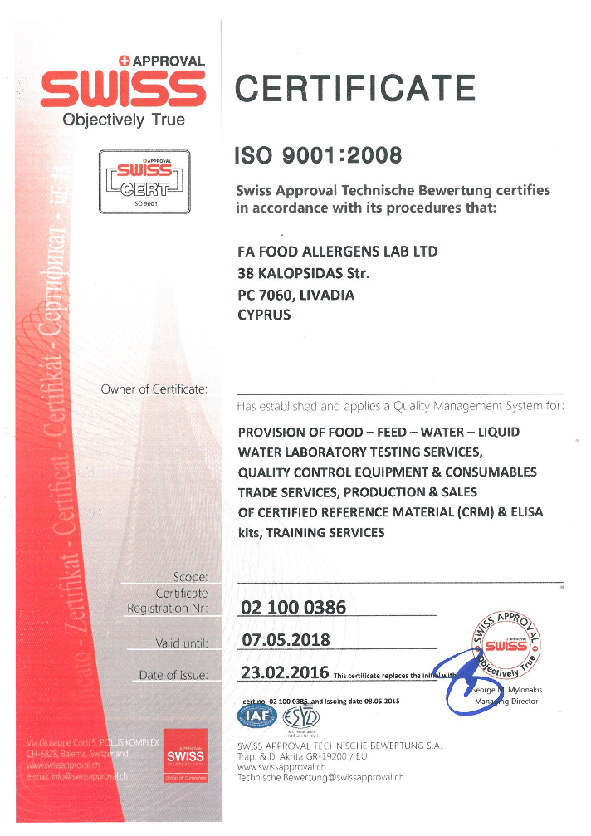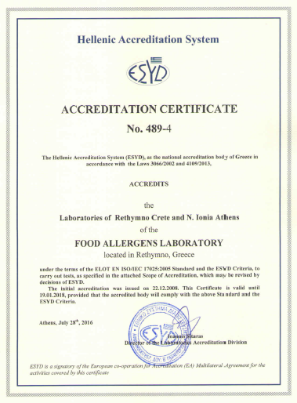**http://esyd.gr/portal/p/esyd/el/showOrgInfo.jsp?id=18407**

**6. CONTACT**

**Laboratories List**

The Food Allergens Laboratory is an international network of testing laboratories covering the full range of tests that can carried out on food products and their raw materials. The company now operates in Greece (Athens and Rethymno), Cyprus (Larnaca) and Poland (Warsaw).

**Staff & Associates in Greece, Cyprus and Poland**

The Food Allergens Laboratory is staffed by highly qualified personnel with significant professional and scientific experience in different sectors of the food chain such as production, food safety management systems, nutritional value, legislation, research and product development, while participating in a variety of European and governmental bodies such as (ELOT, ESYD, GETEF, TEE, BPI, GEOTEE, NAGREF, NRF-EIE, SGL of Greece & Cyprus, University of Athens, Agricultural University of Athens, EKPIZO, CEN, EFSA, BEUC, FOV)

Directors:

* **Andreas Varlamos**, M.Eng, Chemical Engineer NTUA - MSc Food QA Reading UK.

[Chair of Stakeholders Consultative Platform of EFSA, member of EFSA StaCG-Emerging Risks & SHP DG on Chem. Occurrence Data, ex- member of the Headline Food WG BEUC, ex-Chair of the Scientific Committee of Food & Biotechnology of Greek Technical Chamber, ex-member of Greek National Committee for Nutritional Policy, ex-member of General Technical Committee for Certification Bodies of Greek Accreditation Body, ex-member of Food Technical Committee, ex-member of Greek Organization for Standardization, ex-member of Pesticide National Action Plan Committee for the Greek Ministry of Agriculture, etc.]

* **Georgios Seiragakis**, Chemist - MSc in Food Quality Assurance Managment

[member of CEN/TC275 WG12,TAG3( ISO for allergens and pathogens), member of M.B. of the food sector of Greek Chemist Union, ex-lab accreditation assessor of the Greek Accreditation Body (ESYD), former assessor of Eurostars European Programs, ex-member of the Greek Supreme Chemical Council, of General Technical Committee for Testing Laboratories of Greek Accreditation Body, ex-Coordinator of the SEVITEL for G.H.P. in olive oil production, ex-national representative in EU (nominated by SEVT) for application of the Directive IPPC in the food industry, Reviewer of the International Scientific Journal JAOCS.]

Technical Director and Head Research Scientist:

* **Dr. George Miliadis**, Chemist, PhD, with 35years working experience (30 years as Director of National Reference Laboratory: Benaki Phytopathological Institute, Pesticide Residues Laboratory).

[Expert of Food and Veterinary Office (FVO), Vice Chair of Technical Committee and Assessor of the National Accreditation Body for ISO 17025 & ISO 17043, Testing Laboratory Instructor of Quality standards, Analytical techniques and Official Control issues in many different international laboratories projects, Authorized Trainer in Chemical Metrology (TrainMic of EU Commission), Scientific Expert of EFSA, Expert of the European Commission TAIEX, Reviewer of international scientific journals, Chair & member in several scientific committees, More than 190 publications in scientific journals, symposiums & conferences presentations and life sciences-books publishing]

Rest Scientific Staff and other senior-executives

* Agnieszka Ambroziak, Food Engineer – Msc in Nutrition Warsaw University
* Angelogiannakis John, Technologist Agronomist, TEI of Crete
* Antonopoulou Spyridoula, Economist Panteion University of Athens
* Evagelou Vasiliki, PhD Agronomist - M.Sc in Molecular Techniques
* Galanis Nikos, Agronomist – M.Sc in Food Chemistry
* Galliaki Anna, Chemist, University of Crete
* Lampidonis Antonis, Postdoc-PhD Agronomist- M.Sc. in Molecular Biologist
* Paraskevaidi Kleopatra, Agronomist - M.Sc in Food Science and Technology
* Politis Manolis, Molecular Biologist University of Crete - M.Sc in Molecular Biology
* Salasidis Eleftherios, Food technologist, TEI of Thessaly
* Spithouraki Fay, Technologist Agronomist, TEI of Peloponnese
* Tsiantas Petros, Agronomist - M.Sc in Analytical Chemistry
* Tsiantas Konstantinos, Food technologist, TEI of Athens
* Tsintzira Panagiota, Αccountant TEI of Chalkida
* Xristodoulou Elena, Food technologist, TEI of Thessaloniki
* Xristofakis Manolis, Chemist - M.Sc .Sc in Food Biotechnology at Ulster University

|  |  |
| --- | --- |
| **Test Results**  +30 210 2712498 (1) ή 28310 24423, 6945878194 | **Research & Development**  +30 210 2712498 (2) |
| **Sampling, Calibration & Other Services**  0030 210 27 12 498 (3), | **Orders & Offers**  0030 210 27 12 498 (4), 6973375936 |
| **Chemist Lab**  0030 210 27 12 498 (5) | **Accountant’s Office**  0030 210 27 12 498 (6) |
| **Finance Department**  0030 210 27 12 498 (7) | **Law Dpt – Labelling**  0030 210 27 12 498 (7), 6977663478 |
| **Directors**  0030 210 27 12 498 (8), 6978118047 - 6977663478 | |
| Emails: [info@foodallergenslab.com](mailto:info@foodallergenslab.com), [foodallergenslab@gmail.com](mailto:foodallergenslab@gmail.com), [sales.foodallergenslab@gmail.com](mailto:sales.foodallergenslab@gmail.com), [research.foodallergenslab@gmail.com](mailto:research.foodallergenslab@gmail.com), [athens.foodallergenslab@gmail.com](mailto:athens.foodallergenslab@gmail.com), [crete.foodallergenslab@gmail.com](mailto:crete.foodallergenslab@gmail.com), [cyprus.foodallergenslab@gmail.com](mailto:cyprus.foodallergenslab@gmail.com), [poland.foodallergenslab@gmail.com](mailto:poland.foodallergenslab@gmail.com) | |

